Learn spark Mainly for RDD
0：rdd 弹性数据集，不可变，partitioned collection of elements that can be operated on in parallel.
Each RDD具有以下特征：
- a list of partitions
- a function for computing each split
- a list of dependencies on other RDDs
- optionally, a partitioner for key-value rdds
- optionally, a list of preferred locations to compute each split on(eg: block locations for an hdfs file)

1:spark 输入数据的默认task 个数：
解答：分如下情况：
Rdd:
Hadoopfile 计算分片，传递了一个参数 parallelism
Sc.parallelize() 默认值是：spark.default.parallelism
Local mode: number of cores on the local machine

Mesos fine grained mode: 8
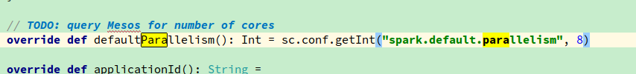
Others: total number of cores on all executor nodes or 2, whichever is larger
Because:YarnSchedulerBackend 继承自CoarseGrainedSchedulerBackend
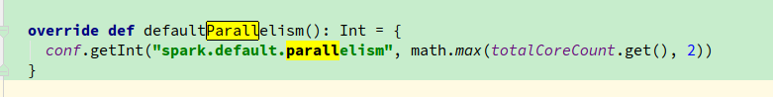
Spark 2.0 中大量使用的Dataset
ExecutedCommandExec
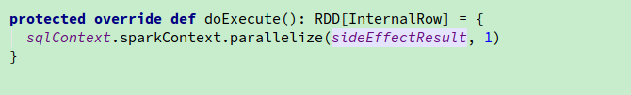

2 慎用 groupBykey ，可能导致oom
* Note: As currently implemented, groupByKey must be able to hold all the key-value pairs for any
* key in memory. If a key has too many values, it can result in an [[OutOfMemoryError]].
It’s recommended to use PairRDDFunctions.aggregateByKey
但是说白了其实语义都不一样，aggregateByKey 是有merge 的效果的

3 join,join函数实现在类PairRDDFunction，该类提供了针对（key，value）pairs rdd 的一些操作。
实现如下：
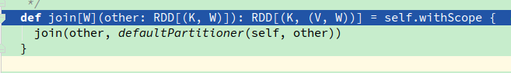
其中defaultPartitioner(self,other)的实现如下：
Partitioner.defaultPartitioner(rdd,rdd*)
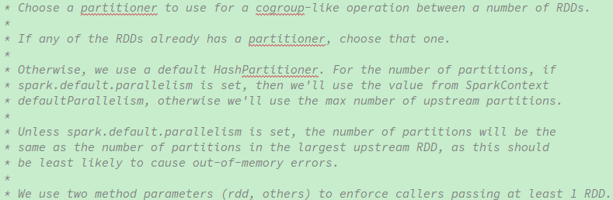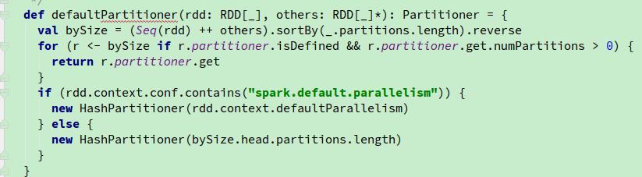

对于上面的排序直观上感觉有点问题，相比与我直接抽取partition个数，然后进行排序

4：对于PairRDDFunction中的操作比如：reduceBykey，aggregateByKey,folyByKey 都是调用了combineBykey.具体见源码。
其实都是对conbimeByKey 在不同语义下的不同实现。
注意：reduceBykey 和 foldByKey 的返回值类型必须和输入一致，而aggregateBKey 却没必要。
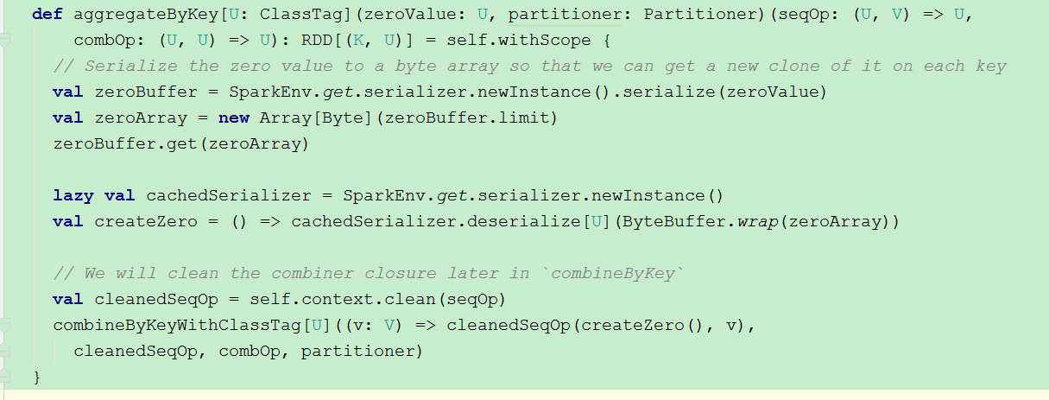
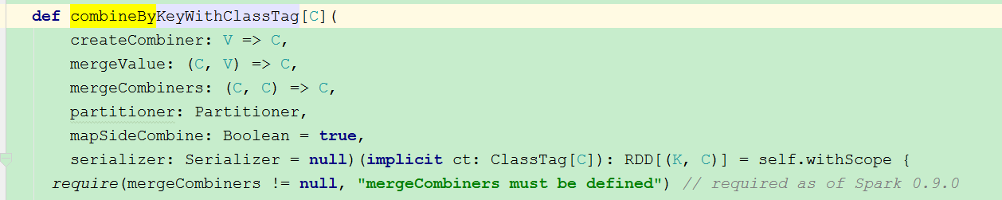
5: takeOrdered: this imp is very interesting
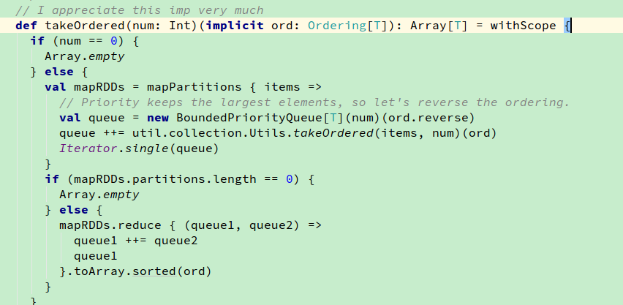

6:take:the same, this imp is perfect, but to be honest, I don’t know why multiply 4 when buf.size == 0,
Besides 1.5*num*PartsScanned/ buf.size
This func is very good, think much about this:
num/buf.size:表示还需要多少个这样的size
* PartsScanned 表示总共需要多少个partition

